YACC

A parser generator is a program that takes as input a specification of a syntax, and produces as output a procedure for recognizing that language. Historically, they are also called compiler-compilers.   
**YACC** (yet another compiler-compiler) is an LALR(1) (Look-Ahead, Left-to-right, Rightmost derivation producer with 1 look-ahead token) parser generator. YACC was originally designed for being complemented by Lex.

Input File:

YACC input file is divided into three parts.

/* definitions */

....

%%

/* rules */

....

%%

/* auxiliary routines */

....

Input File: Definition Part:

* The definition part includes information about the tokens used in the syntax definition:

%token NUMBER

%token ID

* Yacc automatically assigns numbers for tokens, but it can be overridden by

%token NUMBER 621

* Yacc also recognizes single characters as tokens. Therefore, assigned token numbers should not overlap ASCII codes.
* The definition part can include C code external to the definition of the parser and variable declarations, within %{ and %} in the first column.
* It can also include the specification of the starting symbol in the grammar:

%start nonterminal

Input File: Rule Part:

* The rules part contains grammar definition in a modified BNF form.
* Actions is C code in { } and can be embedded inside (Translation schemes).

Input File: Auxiliary Routines Part:

* The auxiliary routines part is only C code.
* It includes function definitions for every function needed in rules part.
* It can also contain the main() function definition if the parser is going to be run as a program.
* The main() function must call the function yyparse().

Input File:

* If yylex() is not defined in the auxiliary routines sections, then it should be included:

#include "lex.yy.c"

* YACC input file generally finishes with:

.y

Output Files:

* The output of YACC is a file named y.tab.c
* If it contains the main() definition, it must be compiled to be executable.
* Otherwise, the code can be an external function definition for the function int yyparse()
* If called with the –d option in the command line, Yacc produces as output a header file y.tab.h with all its specific definition (particularly important are token definitions to be included, for example, in a Lex input file).
* If called with the –v option, Yacc produces as output a file y.output containing a textual description of the LALR(1) parsing table used by the parser. This is useful for tracking down how the parser solves conflicts.

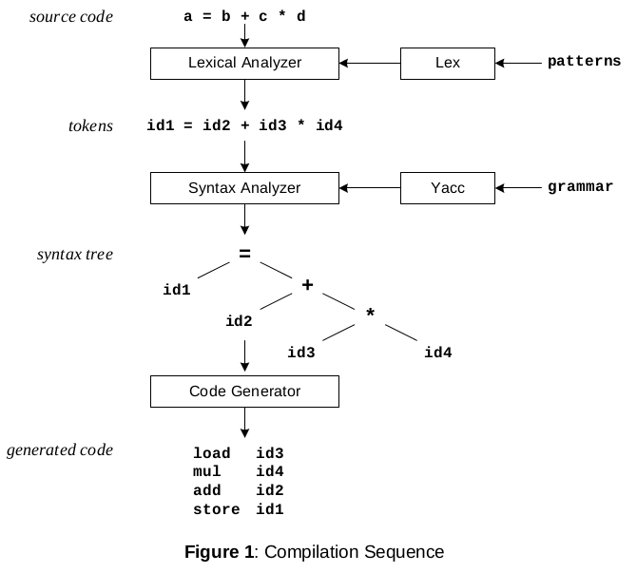

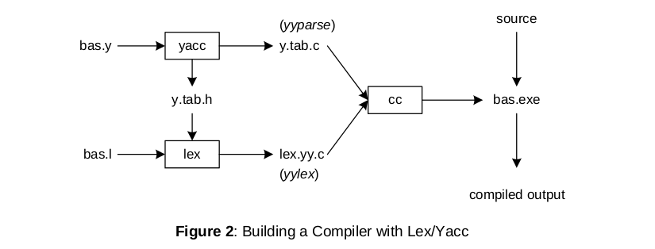

Example

Yacc File (.y)

%{

#include <ctype.h>

#include <stdio.h>

#define YYSTYPE double /* double type for yacc stack */

%}

%%

Lines : Lines S '\n' { printf("OK \n"); }

| S '\n'

| error '\n' {yyerror("Error: reenter last line:");

yyerrok; };

S : '(' S ')'

| '[' S ']'

| /* empty */ ;

%%

void yyerror(char * s)

/* yacc error handler */

{

fprintf (stderr, "%s\n", s);

}

int main(void)

{

return yyparse();

}

Lex File (.l)

%{

%}

%%

[ \t] { /* skip blanks and tabs */ }

\n|. { return yytext[0]; }

%%

For Compiling YACC Program:

1. Write lex program in a file file.l and yacc in a file file.y
2. Open Terminal and Navigate to the Directory where you have saved the files.
3. type lex file.l
4. type yacc file.y
5. type cc lex.yy.c y.tab.c -ll -w
6. type ./a.out